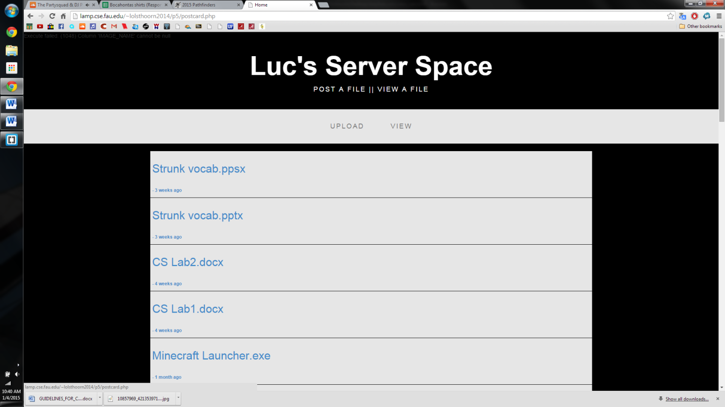EXAMPLES OF WORK

Server Space that I created to hold my data, while still having a client side accessing.

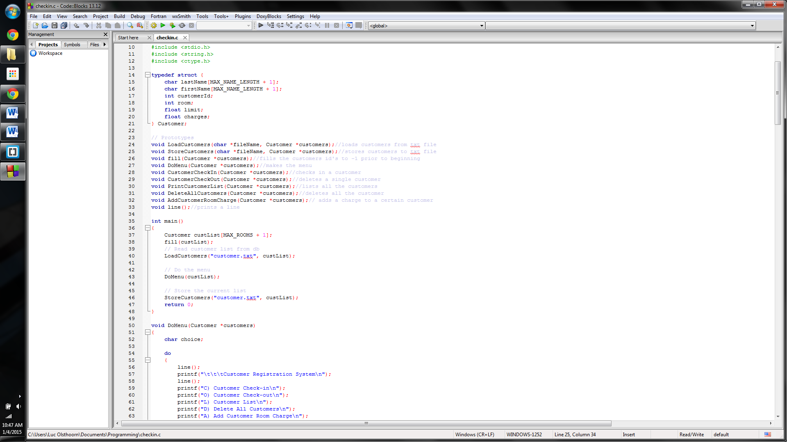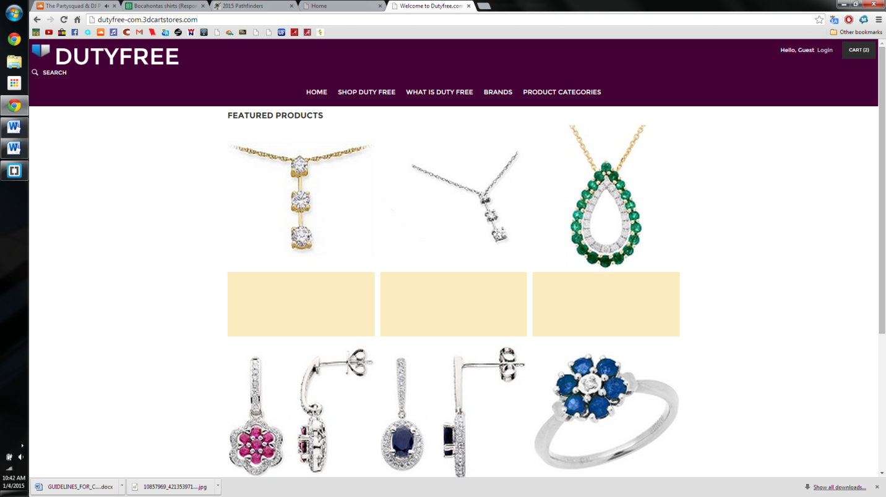Website that I do web work for, Duty Free.com